**Oyster Task Force Meeting Minutes**

**Tuesday, February 18, 2025, 10:00am**

**New Orleans Lakefront Airport**

**6001 Stars and Stripes Blvd.**

**New Orleans, LA**

**I.** Pledge of Allegiance

**II.** Roll call and introduction of guests

**Voting Members Present:**

Jakov Jurisic

Mitch Jurisich

Brad Robin

Brandt Lafrance

Sam Slavich

Peter Vujnovich

Willie Daisy

Steve Pollock

**Voting Members Absent:**

Shane Bagala

Dan Coulon

Brandon Debarge

Al Sunseri

Matthew Slavich

**Non-Voting Members Present:**

Robert Caballero

Davis Madere

Kyle Balkum

**Non-Voting Members Absent:**

Justin Crossie

Brian Lezina

**III.** Brad Robin motioned to approve the January 8, 2025 meeting minutes, 2nd by Brandt Lafrance. Motion carries

Brad Robin motioned to amend the agenda by adding an item to the agenda under new business, “J. To Consider Funding for the OTF Super Bowl Event to Include Oysters and Signage, 2nd by Brandt Lafrance. Motion carries.

Brad Robin motion to accept the agenda as amended, 2nd by Brandt Lafrance. Motion carries.

**IV.** Treasury Report:

Remaining Fund Balance: $530,589

Remaining Budget Balance: $139,346

Peter Vujnovich motioned to approve the Treasury Report as presented, 2nd by Brad Robin. Motion carries.

**V.** Committee Reports

A. Public Private Oyster Seed Grounds Committee- no report

B. Enforcement Committee: Davis Madere provided the enforcement report

12/16/2024 – 1/31/2025

**Region 4** (Iberia)

**Region 5** (Calcasieu and Cameron)

**Cameron**

RS 56:424E(1)- Take oysters from unapproved area

**Seizures:** 75lbs oysters

**Vermillion**

56:449E- Poss. Less than 10% untagged/ improperly tagged oysters

**Seizures:** 1- mini sack

**Region 6**: (Terrebonne, Lafourche, Grand Isle, St. Mary)

Lafourche

RS 56:109B Not abiding by rules and regulations on WMA (Harvest oysters from WMA)

19 counts of RS 56:303.1.1 Commercial Fresh Products Licensee Fail to report or maintain records.

5 counts of RS 56:303.7 Fail to complete trip tickets

RS 56:449E Possession on untagged/ Improperly tagged oysters.

3 citations for RS 56:301.1B Fishing without a license resident.

3 citations for RS 56301.1B Fishing without a salt water license resident.

**Seizures:**

**¼ sack, 8 mini sacks, and 20 whole oysters.**

**Region 8**: (Jefferson, Plaquemines, St. Bernard, Orleans)

**St. Bernard**

3 - RS 56: 433 A – Take Undersized Oysters from Natural Reef.

3 - Warning – RS 56: 433 A – Take Undersized Oysters from Natural Reef. (First Offense)

**Seizures:**

16- Sacks seized in connection with these violations and returned to water.

**Plaquemines**

**Seizures:**

C. Legislative Committee: The committee plans to meet prior to the next OTF meeting to discuss 2025 oyster legislative items

D. Legal Committee- no report

E. Research Committee: Earl Melancon provided an update, stating that CRCL will host the State of the Coast Conference in May, Panel on May 20th @ 2:00pm at the Morel Convention Center; 90 minute session- Robert Caballero and Denise Kinsey from LDWF will provide a short presentation; 6 panelist- 2 growers from traditional industry and 2 off-bottom growers on the panel, will also have 2 processors; Panelist registration fee is covered by grant funding

Thomas Hymel with LSU Ag, LA Sea Grant to host a full day meeting at the LSU Ag Center Iberia Research Station, ‘Visioning the Future of Our LA Oyster Industry’ primarily for marketing and producers, talking about products and imports

Planning to have two workshops coordinated with LDWF Enforcement and LDH in Cameron and Grand Isle to discuss the legal aspects of harvesting oysters and moving them to market and making sure personnel have an understanding of what AOC is

F. Coastal Restoration Committee- Captain George Ricks stated that on Feb. 3 both diversions open Davis pond and Caernarvon, Caernarvon was running at 8000CFS and Davis Pond was running at 9000CFS, they shut Caernarvon down Feb 14th, as we speak Davis Pond is running at 6000CFS, attended CPRA’s annual planning meeting in Jefferson Parish, 133 projects in the annual plan boasting $1.8 billion in 2026 Annual Plan, Mid-Barataria and Mid-Bretton not mentioned in Annual Plan but there is funding appropriated for both of these projects, public comment ends on March 21st to comment on annual plan, suggested that the task force consider submitted comment

G. Marketing Committee- Anna Koehl provided an update stating that on Jan 22, 2025 the OTF hosted the Let the World Be Your Oyster event, the turnout was lower than anticipated due to the snow event in Louisiana, Dauphine’s venue in Washington, D.C. was great, results from last task force meeting from paid digital campaign, over 245,423 views of the digital ads and email campaign, almost 1000 clicks to the website

OTF hosted a Super Bowl event on Super Bowl Sunday at the LA NOW Pavilion, great turnout- 300-500 people attended

Mitch Jurisich thanked Anna Koehl for all of her work on these two events

The task force is planning to start planning for 2026 DC Mardi Gras and related events after Mardi Gras

H. Health Committee: Jennifer Armentor stated that the Health Committee met this morning to discuss the recent Area 3 closure and recall- 238 cases confirmed and 8 suspected, initially wanted to identify harvest area and it exploded to so many cases and the amount of tags and due to the magnitude decided to keep the whole area closed for 21 days, if individuals put oysters back on leases in this area they will need to be closed for 60 days; talked about what can be done better and it was decided to get with the industry before recall is made, work to get expedited information to narrow down the area of issue, the Task Force and Health department are seeking to look into splitting Area 3 into sections in the future

John Tesvich recommended that the task force take action today to split up Area 3

Jakov Jurisic motioned for LDH and LDWF to split Area 3 into separate areas2nd by Brad Robin. Motion carries.

Patrick Banks stated that this change would most probably take rule making on behalf of LDH

I. Aquaculture Committee- no report

J. Joint Task Force Working Group- no report

**VI.** New Business

1. Patrick Banks provided a quick update on the oyster lease moratorium lifting

The rules that were enacted requires you to complete the previous phase before moving to the next phase, still lacking 3 applications that have some legal issues due to some land rights that need to be cleared up, can’t move to phase 1 until phase 0 is completed, one of the biggest issues is dealing with the dual claims issue, have to enter into a dual claim agreement and this is what is the big hold up, all of the phases will most probably have some dual claims issues that require agreements to be made between the two groups

1. Jason Froeba provided an update on the equipment grant program

* 1,749 applications submitted
* 1,439 (82%) application started of completed review process
  + # Paid or approved for payment – 862
  + # Ineligible – 111 (3 due to inspection)
  + # Waiting on inspection – 36
  + # Approved waiting for reimbursement request/invoices – 38
  + # Under review - 392
* $38,200,000 total program funding
* $22,266,650.94 of funding has been paid
* Additional $1,191,602.65 awarded waiting to be paid
* $914,228.06 awaiting inspection
* $13,230,000 assigned to applications under review (assumes full $30k and eligible)
  + Given average award amounts and current eligibility percentage we expect this to result in $10.7 million in awards
* $597,518.35 remaining to be assigned
  + 19 applications left to assign (assumes full $30k) – fully assigned next week
  + Given average award amounts and current eligibility percentage we estimate $3.2 million left to assign
  + Estimated 130 applications left to exhaust current funding
    - After assigning the remaining 19, new review assignments will only occur as funding becomes available
* Estimate we need to review 1,569 applications to exhaust funding
  + Estimate 180 applications will not get reviewed or receive funding (Starting 12/20/23)
  + Program is oversubscribed by $4.4-5.4 million

John Tesvich applied for this program sometime last year, last notice received Aug 2024, ask that admin sends out courtesy email, send update to those still awaiting review

1. Chris Lemarie led discussion on the pollution line and oyster mapping

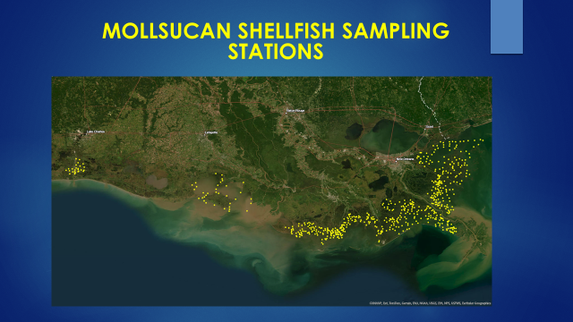

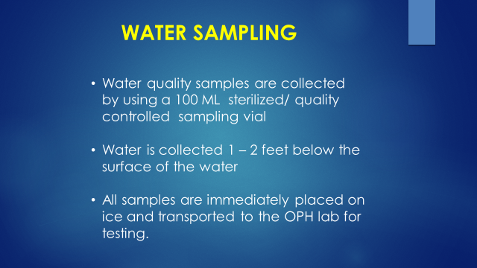



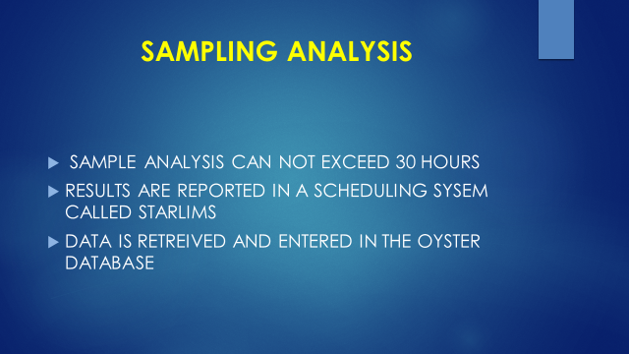

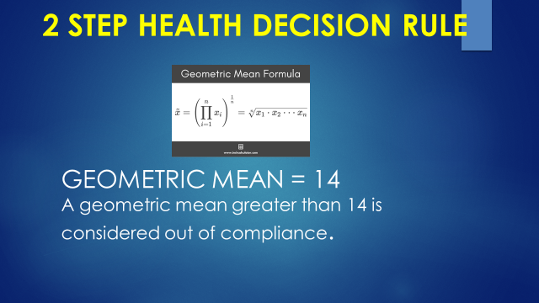

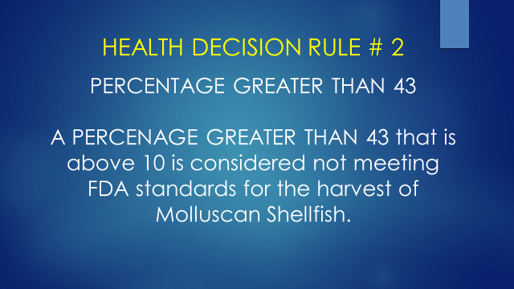

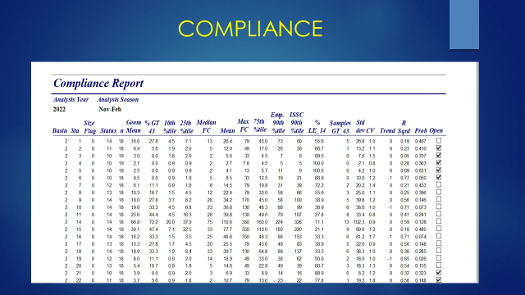

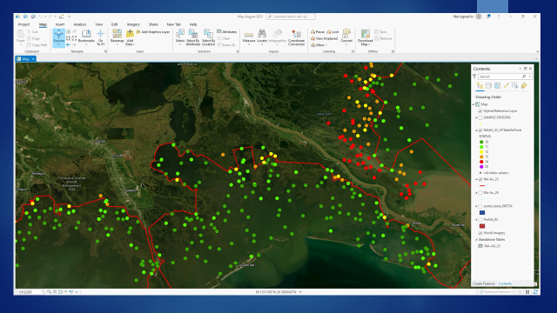

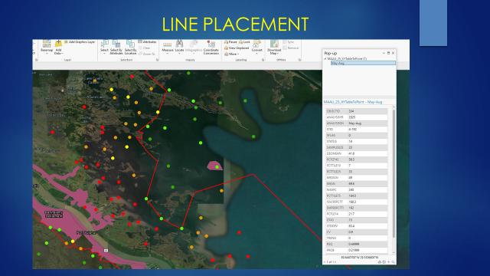

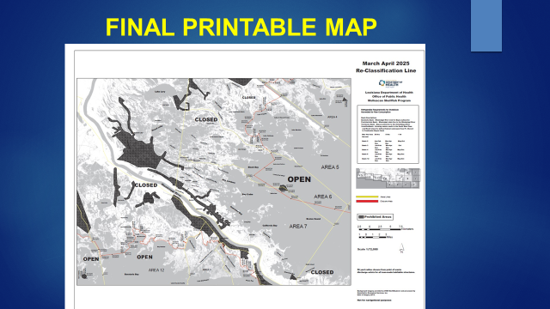

Brad Robin soon will have nothing open to fish, water quality of some of these areas is no good the only thing that has changed is the closing of the MRGO, the crevasses are causing issues

Chris Lemarie stated that Area 3 can be sectioned off, may be some legislation involved but will have to look into it

1. Sam Slavich led discussion on the Oyster Harvester Training began process of renewing oyster harvesters license in December and received license on Feb 5, should probably take some kind of action, would like to make a request of the license section, the number of licenses issued under the mandate of training and compare that to prior and see what affect the testing is having on the number of license issued

Sam Slavich motioned to make a request to the LDWF licensing section to provide some data analysis to the task force on the number of licenses issued during the training mandate as compared to before the training mandate, 2nd by Jakov Jurisic. Motion carries.

Robert Caballero stated that due to historic floods and the pandemic licensing numbers will be skewed and it may have nothing to do with harvester training

Ante Tesvich recommended that LDWF look into an electronic system for licensing, had to apply for 18 LDWF licenses and hard to make sure that every employees has the correct license on hand an electronic system or LA wallet that would allow people to have an electronic copy on hand and not have to have the physical copy would help

1. Sandy Garcia provided a presentation on the WWLTV campaign



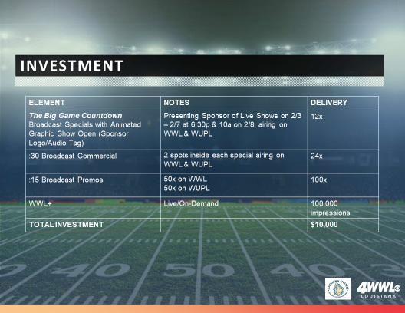

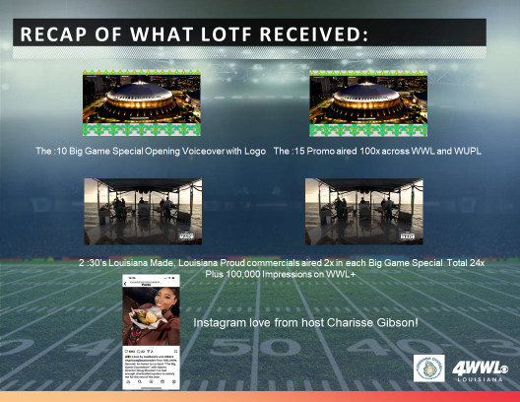

Brad Robin motioned to approve funding $10,000 for a WWLTV Super Bowl campaign, 2nd by Brandt Lafrance. Motion carries.

1. The task force considered funding to hire a legislative representative

Last contract ended under the Jindal admin, the representative would monitor committee meetings and legislation pertaining to the oyster industry, would serve at the direction of the chairman and the legislative committee, this position would just provide information of what’s out there a reporting and monitoring position for the task force

Brad Robin motioned to fund up to $15,000 to hire a legislative representative for the Oyster Task Force, no second. Motion removed.

Eric Sunstrom plans to bring a contract to the task force and they will then come up with funding and budget at a future meeting

1. The task force considered funding to reimburse Mitch Jurisich for the Let the World Be Your Oyster invitation printing and mailing fees

Peter Vujnovich motioned to reimburse Mitch Jurisich in the amount of $2437.01 for invitation printing and mailing fees, 2nd by Brad Robin. Motion carries.

1. The board discussed adding a new seat to the OTF for a representative from the LA Department of Ag and Forestry

Peter Vujnovich motioned that the task force move forward with legislation on adding a seat for a LA Department of Ag and Forestry representative to the Oyster Task Force, 2nd by Steve Pollock. Motion carries.

1. The task force considered funding to purchase an OTF table cloth

The task force would like to purchase two royal blue tablecloths that have a silver OTF logo

Brad Robin motioned to approve purchasing two Oyster Task Force tablecloths, 2nd by Jakov Jurisic.

1. The board considered funding for oysters served at their Super Bowl event and payment for signage that was printed; the signage costs equaled $52.54, and the oysters provided costs, $325

Brad Robin motioned to fund the printing of signage in the amount of $52.54 and oysters in the amount of $325.00 for the Oyster Task Force Super Bowl event, 2nd by Brandt Lafrance. Motion carries.

**VII.** Public comment

Dr. John Zach Lea stated that he is working on redeveloping and would provide a part of his lab to learn the business and during the year can help them get their own AOC permit; Jakov Jurisic suggested referring this offer to AOC Committee and bring it back to the board

Buddy Pausina stated that the OLDEB was looking to update procedures and decide on what the cost is to harvest a sack of oysters, the OTF looked at it and went through and developed a good procedure to handle this on an individual lease basis, the OLDEB is going to meet in the next month and would like the task force’s recommendation on the oyster harvesting costs sent over, requested a letter with the task force’s recommendation

**VIII.** Next meeting set for ~~Tuesday, March 18~~~~th~~ Wednesday, March 19th for 10:00am at the New Orleans Lakefront Airport; Legislative Committee meeting prior beginning at 9:00am

**IX.** Jakov Jurisic motioned to adjourn the meeting, 2nd by Brad Robin. Motion carries.